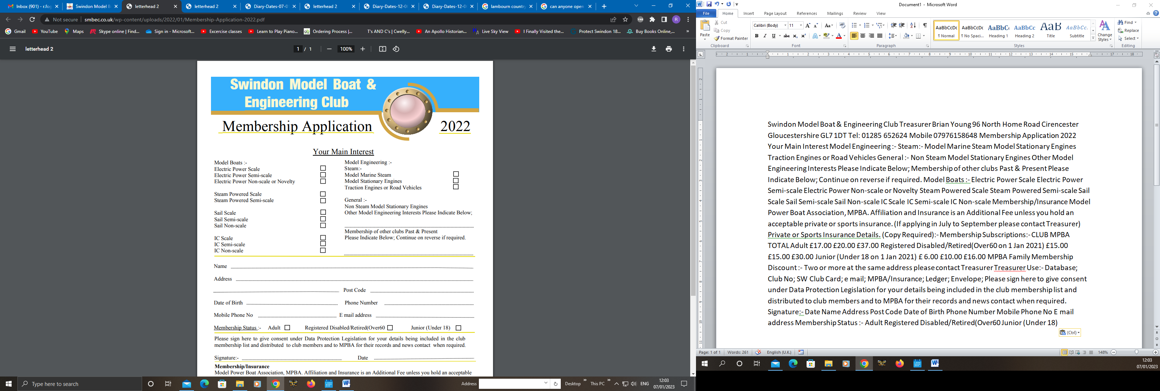

2023

Your Details

Name:- ………………………………………………………………………………………..

Address:- ……………………………………………………………………………………...

Post Code:- ………………. Date of Birth:- ……………. Phone Number:- …………...

Mobile Number:- …………………… E-mail Address:- ………………………………….

Membership Status:- Adult □ Registered Disabled / Retired (Over 60) □

Junior (Under 18) □

Please sign here to give your consent under Data Protection Legislation for your details being included in the Club Membership List and distributed to Club Members and to the MPBA for their records and news contact when required.

Signature:- ………………………………. Date:- …………………..

**Membership / Insurance**

Model Power Boat Association (MPBA). Affiliation and Insurance is an Additional Fee unless you hold an acceptable private or sports insurance e.g. BMFA. (If applying in July to September please contact the Treasurer).

Private or Sports Insurance Details. (Copy Required):- ………………………………………

|  |  |  |  |
| --- | --- | --- | --- |
| Membership Subscriptions:- | CLUB | MPBA | TOTAL |
| Adult | £17.00 | £20.00 | £37.00 |
| Registered Disabled / Retired (Over 60 on 1st January 2023) | £15.00 | £15.00 | £30.00 |
| Junior (Under 18 on 1st January 2023) | £6.00 | £10.00 | £16.00 |
| MPBA Family Membership Discount :- Two or more at the same address, please contact the Treasurer | | | |

*Please fill in the Form above and email to Bob Hobbs (details below) and take a cheque made payable to the “Swindon Model Boat and Engineering Club” to the next monthly meeting. Alternatively post your cheque to Bob in a self-addressed envelope and Bob will return your Membership Card.*

Treasurer Use:-

|  |  |  |
| --- | --- | --- |
| Database □ | Club No: SW…… □ | Club Card □ |
| E-mail  □ | MPBA / Insurance □ | Ledger □ |

Treasurer and Membership Secretary:- Bob Hobbs Email: triumphaustinman@gmail.com

Telephone – 01249 821230 Paddock House, Fishers Brook, Calne, Wilts, SN11 9HB

